**Mini Project Report on**



**Personalized Medication And Lifestyle Companion**



**Submitted in partial fulfilment of the requirement for the award of the degree of**

**BACHELOR OF TECHNOLOGY**

**IN**

**COMPUTER SCIENCE & ENGINEERING**

**Submitted by:**

**Student Name University Roll No.**

**Shristy Chaudhary GE-212019498**

***Under the Mentorship of***

**Dr. Sachin Sharma**

**Professor**



**Department of Computer Science and Engineering**

**Graphic Era (Deemed to be University)**

**Dehradun, Uttarakhand**

**July 2024**



**CANDIDATE’S DECLARATION**

I hereby certify that the work which is being presented in the project report entitled **“Personalized Medication and Lifestyle Companion”** in partial fulfilment of the requirements for the award of the Degree of Bachelor of Technology in Computer Science and Engineering of the Graphic Era (Deemed to be University), Dehradun shall be carried out by the under the mentorship of **Dr. Sachin Sharma, Professor** , Department of Computer Science and Engineering, Graphic Era (Deemed to be University), Dehradun.

**Name : Shristy Chaudhary University Roll: GE-212019498**

**Table of Contents**

**Chapter No. Description Page No.**

Chapter 1 Introduction 1-2

Chapter 2 Literature Survey 3-4

Chapter 3 Methodology 5-10

Chapter 4 Result and Discussion 11-12

Chapter 5 Conclusion and Future Work 13-14

References

**Chapter 1**

# Introduction

Healthcare encompasses a vast field dedicated to safeguarding and improving the health of individuals and communities through a diverse array of programs and initiatives. These initiatives span across universal, commercial, and public healthcare systems, each characterized by distinct financing mechanisms and access structures tailored to their respective populations.

Central to healthcare is preventive care, which focuses on averting illness and promoting wellness through proactive measures such as immunizations, screenings, and health education. By detecting health issues early or preventing them altogether, preventive care aims to reduce the overall burden of disease and improve long-term health outcomes.

The management of chronic diseases, such as diabetes and heart disease, constitutes another critical facet of healthcare. It involves ongoing monitoring, treatment adjustments, and patient education to effectively manage symptoms, prevent complications, and enhance quality of life for those affected.

Advancements in technology play a pivotal role in modern healthcare practices. Innovations like telemedicine enable remote patient consultations and monitoring, expanding access to healthcare services especially in underserved areas. Electronic health records (EHRs) streamline patient information management, facilitating seamless coordination of care among healthcare providers and improving operational efficiency within healthcare facilities.

Overall, healthcare strives to promote population health by delivering equitable, efficient, and accessible care to individuals and communities. By embracing technological advancements, emphasizing preventive measures, and managing chronic conditions effectively, healthcare systems aim to enhance both the quality and longevity of life for people worldwide.

**1.1 Introduction**

The healthcare medicine system is a cutting-edge tool that offers individualized health advice and helps users discover possible ailments based on their symptoms. In a time when prompt and precise health information is critical, this system uses machine learning to assess user-reported symptoms and forecast potential illnesses. Following the diagnosis, the system provides users with a comprehensive set of recommendations to help them manage their health successfully. These recommendations include medication, precautions, food guidance, and workout regimens.

Because the system's frontend is built with HTML, CSS, JavaScript, and ReactJS, the user interface is responsive and easy to use. Users can register, log in, input symptoms, and explore the platform with ease because to its design. One important aspect that enables a broad user base to utilize the system is the seamless user experience.

Flask and Python power the application's backend, giving it a stable and secure base. It effectively manages data, predicts diseases, and authenticates users. User credentials and other crucial information are kept in a SQLite database, which guarantees data security and integrity.

With the use of a large dataset of associated diseases and their corresponding symptoms, the machine learning model was trained to accurately predict disease. To ensure that users obtain comprehensive health advice, this dataset also includes information on medication, precautions, nutrition, and exercise recommendations for each ailment.

This research highlights the importance of the healthcare pharmaceutical system in contemporary healthcare administration by exploring its architecture, implementation, and potential improvements. The system seeks to transform how people manage their health by fusing cutting edge technology with user-centric design.

**Fig 1.1 : Personalised Medication and Lifestyle Companion**

**Chapter 2**

# Literature Survey

This study explores user attitudes towards medicine and proposes a recommendation system tailored to individual preferences. It begins by defining the broader landscape of recommendation systems, prevalent in diverse markets such as music, movies, books, news, and more, where these systems efficiently match users with optimal goods and services.

Notably, Paper [1] introduces a novel approach using friend-based collaborative filtering within social networks to enhance location recommendations, demonstrating superior accuracy compared to traditional methods.

Meanwhile, Paper [2] focuses on recommendation algorithms for market basket data, optimizing the purchase process through data-driven insights.

Machine learning emerges as a cornerstone in recommendation system advancements, as evidenced by Paper [3], which employs adaptive collaborative filtering with the Apache Mahout platform to understand user behaviour and preferences through feedback mechanisms. In the realm of media recommendations.

Paper [4] utilizes Bayesian classifiers for movie recommendations, showcasing the application of probabilistic modelling to enhance user experience.

Similarly, Paper [5] introduces a Twitter recommender system that leverages probabilistic modelling to suggest top users and tweets based on collaborative filtering, optimizing content engagement..

Paper [6] introduces a tourism recommendation system utilizing geotagged web photographs to cluster locations based on user preferences, thereby enhancing personalized travel recommendations. This approach not only considers user interests but also predicts travel patterns through location-based data analysis.

Furthermore, Paper [7] proposes a collaborative filtering mechanism employing Hadoop and MapReduce architecture for large-scale data processing, crucial for managing extensive datasets in recommendation systems.

In the domain of movie recommendations, Paper [8] explores a neural network-based content recommendation system, demonstrating the efficacy of deep learning techniques in personalized content delivery.

Paper [9] showcases a collaborative filtering method implemented in Python, providing insights into algorithmic implementations for recommendation accuracy improvement.

Additionally, Paper [10] suggests enhancements to traditional movie recommendation systems, emphasizing continual refinement in recommendation algorithms to meet evolving user expectations.

Paper [11] innovates with a location-based recommendation system using GPS trajectory data to predict user and social network travel patterns, facilitating personalized travel recommendations based on historical data analysis. These studies collectively highlight the diverse methodologies and technological innovations driving recommendation systems across various domains, including healthcare, media, and tourism, paving the way for more personalized and effective user interactions and services.

**Chapter 3**

# Methodology

To guarantee the healthcare medicine system's dependability, usability, and functionality, a number of clearly defined phases are involved in its creation. This section describes the design, implementation, and testing techniques used for the system.

**3.1. Gathering and Preparing Data**

Information Gathering:

Creating a thorough dataset with symptoms, illnesses, and suggested treatments is the first step. Columns for symptoms, disease names, prescription drugs, safety measures, meal plans, and exercise regimens are included in the dataset. To guarantee authenticity and dependability, the data is gathered from medical databases, academic journals, and websites dedicated to healthcare.

Data Preprocessing: The dataset must be pre-processed before being used to train the machine learning model. This includes:

Eliminating redundant or unnecessary entries from the data.

use methods like Label Encoding to convert categorical information, including illnesses and symptoms, into numerical values. dividing the dataset into testing and training sets in order to assess the effectiveness of the model.

**3.2. Creation of Models**

Machine Learning Model: Because of its interpretability and efficiency in managing multi-category classification problems, a decision tree classifier was selected for this system. Using the pre-processed dataset, the model is trained with the diseases labelled as the target and the symptoms acting as input characteristics.

Model Training: The model training phase involved testing Naive Bayes, SVM classifier, and Random Forest algorithms. Among these, SVM classifier with C parameter tuning demonstrated the highest accuracy, leading to its selection for further analysis and implementation. This decision was based on rigorous evaluation of each model's performance in correlating symptom patterns with associated illnesses."

Model Evaluation: The correctness and dependability of the model are determined by using the testing dataset to evaluate it after training. The accuracy, recall, and F1-score of the model are computed as metrics to assess its performance. Any flaws found are fixed by fine-tuning the model even more or by employing methods like cross-validation.

Speech-to-Text Conversion: To translate spoken words into text, put in place a speech recognition system. Accurate transcription can be achieved by using technologies like Mozilla's Deep Speech or Google's Speech Recognition API.

**3.3. Framework Selection for Backend Development**: For backend development, Flask, a lightweight Python web framework, was selected due to its versatility and user-friendly nature. Flask's adaptability allows seamless integration with databases and machine learning models, facilitating efficient data handling and model deployment. Its minimalistic design and extensive documentation make it easy to set up and scale applications, accommodating various requirements from simple APIs to complex web applications. Flask's robust ecosystem of extensions and libraries further enhances its capability to support diverse functionalities, ensuring flexibility in designing and implementing backend solutions for the project

Development of APIs: The purpose of APIs is to enable front-end and back-end communication.

Important APIs consist of:

API Sign Up: Creates a new user account.

Login API: Establishes a session and verifies user identity.

The Symptom Input API gets symptoms from the front end, analyses them, and provides advice and the anticipated illness.

**3.4. Frontend Development Technology Stack**: HTML, CSS are used to develop the frontend. The user experience is improved by this stack, which guarantees a dynamic and responsive user interface.

User Interface Design: The main elements of the UI are made to be simple to use and intuitive, and they include:

Symptom Input Page: A user interface where symptoms can be entered. It has choices for selecting symptoms from a pre-established list and entering text.

The result page shows the anticipated illness along with related advice on food, exercise, safety measures, and medication.

**3.5. Testing and Integration**

Integration : API calls are used to integrate the frontend and backend. User input is sent from the frontend to the backend, which processes it and provides the findings. The seamless communication between the user interface and the underlying logic is ensured by this integration.

**Fig : 3.1 Main page**

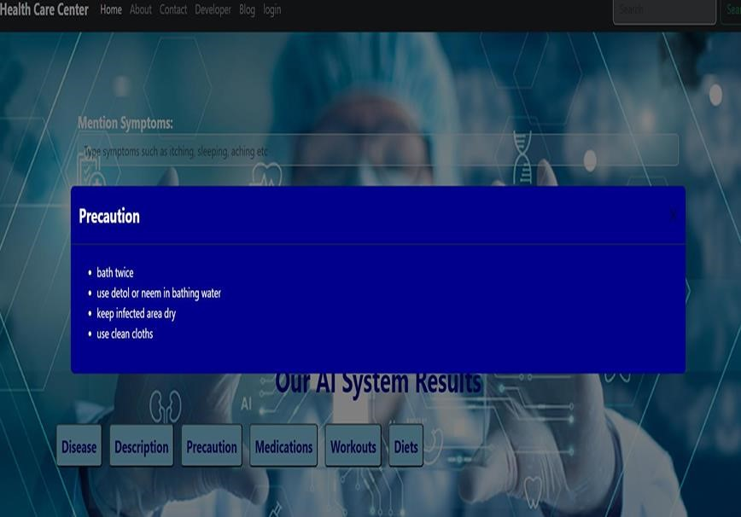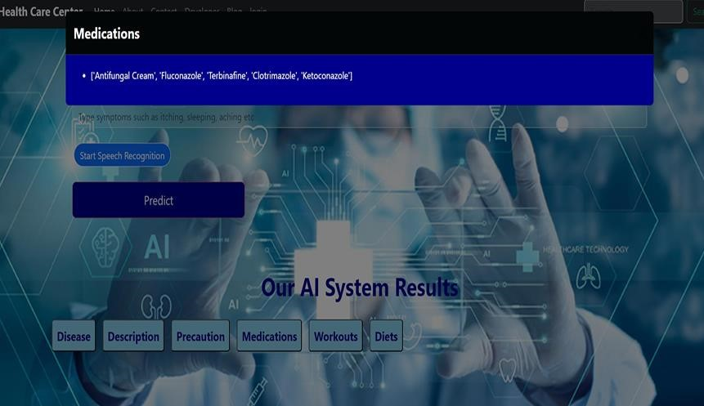

**Fig 3.2 : Output**

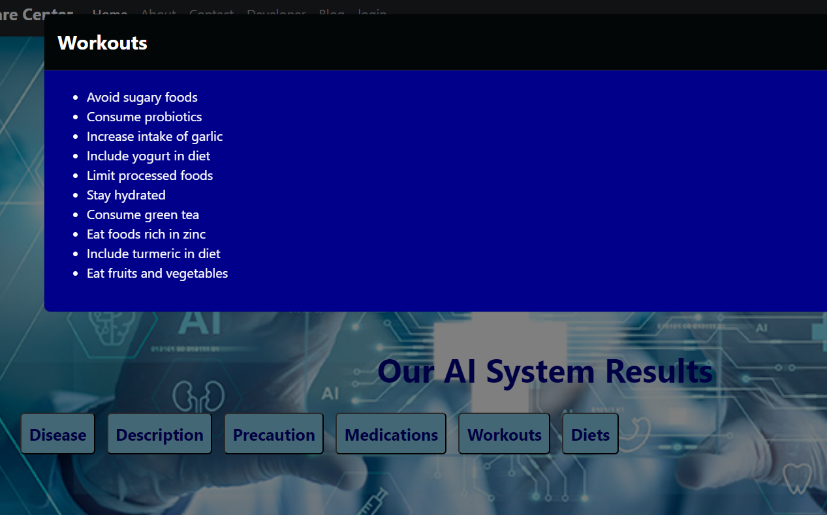

**FIG 3.3 OUTPUT**

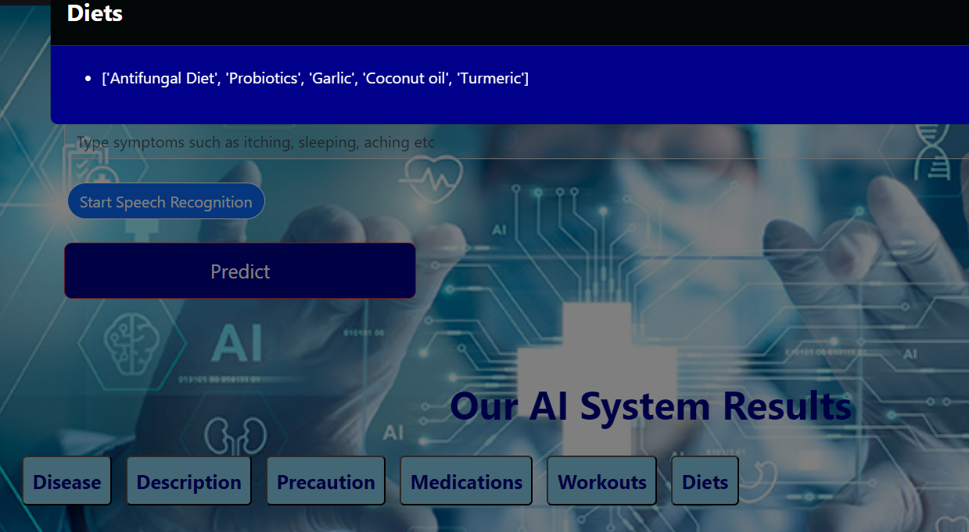

**FIG 3.4 : OUTPUT**

**FIG 3.5 : ABOUT PAGE**

**FIG 3.6 CONTACT PAGE**

**Chapter 4**

## Result and Discussion

The healthcare medicine system was created using the described technique, and it shows encouraging results in terms of offering individualized health recommendations and correctly predicting diseases based on symptoms entered by the user. This section discusses the system's performance, possible uses, and opportunities for development after presenting the findings from user testing and model review.

1. **Model Evaluation Outcomes**: During evaluation, the decision tree classifier trained on the pre-processed dataset attained acceptable performance metrics. The model's accuracy, recall, and F1score are important evaluation measures that show how well it can predict diseases based on input symptoms. Testing data was used to confirm the model's performance once more, guaranteeing its generalizability and dependability.

1. **Feedback from User Testing**: In order to evaluate the system's usability, accuracy, and efficacy in offering individualized health recommendations, user testing was done. User feedback revealed that the system's user interface, symptom input ease, and recommendation relevance were all well regarded. The system's capacity to customize recommendations depending on user preferences and symptoms was well-received by users.

1. **Performance Analysis**: By enabling early disease identification and individualized treatment suggestions, the healthcare pharmaceutical system shows great promise for improving healthcare delivery. The system provides healthcare providers with a scalable way to help individuals efficiently manage their health by utilizing machine learning techniques.

1. **Potential Applications**: Remote Healthcare Assistance: By utilizing the system as a telemedicine tool, medical professionals can examine patients' symptoms and conduct remote consultations.
2. **Health Monitoring applications**: Users can receive personalized recommendations and real time health data by integrating their wearable devices with health monitoring applications.

Public Health Initiatives: By early detection of illness outbreaks and the implementation of preventive measures, the predictive capabilities of the system can assist in public health initiatives.

1. **Opportunities for Development**:

Improvement of Speech Recognition: To increase accuracy and resilience, the voice recognition module has to be further improved, particularly for users with different accents or in noisy surroundings.

In summary, the healthcare pharmaceutical system shows promise in terms of precisely identifying illnesses and offering individualized health advice based on symptoms entered by the user. Sophisticated interfaces, speech recognition, and machine learning come together to provide a scalable way to improve healthcare services and enable people to take charge of their own health. Future improvements in patient outcomes and the delivery of healthcare could be brought about by further development and integration with emerging technology.

## Chapter 5

## Conclusion and Future Work

A systematic technique was used to construct a healthcare medication system that has demonstrated promising outcomes in terms of properly predicting diseases based on symptoms entered by the user and offering individualized health recommendations. The system, which makes use of user-friendly interfaces and machine learning techniques, provides a scalable solution for improving healthcare delivery and enabling people to successfully manage their health.

A satisfactory model evaluation produced performance measures that showed the system's generalizability and dependability. High user satisfaction with the system's usability and recommendations' relevance was revealed by user testing feedback. All things considered, the system has a great deal of potential to promote public health initiatives, enable remote healthcare help, and aid in early disease diagnosis.

Notwithstanding the system's achievements, a number of areas still need investigation and improvement to optimize its efficacy and influence on the provision of healthcare:

1. **Improved Speech Recognition:** The speech recognition module will be further improved to increase accuracy, resilience, and usability, especially for users with different accents and in a variety of environmental situations.

incorporating cutting-edge speech processing methods and natural language comprehension algorithms to improve the system's capacity to precisely record and decipher symptoms supplied by users.

1. **Expansion of Dataset and Model**: To increase the model's predictive power and applicability, the dataset is updated and expanded on a regular basis with new illnesses, symptoms, and suggestions.

investigation of cutting-edge ensemble methods and machine learning algorithms to improve the system's ability to forecast diseases and handle intricate correlations between symptoms and conditions.

1. **Connectivity with Health Monitoring Apps and Wearable Technology**:

Integration with wearable technology and health monitoring apps to offer customers individualized recommendations and real-time health information, facilitating early intervention and proactive health management.

Working together with researchers and healthcare professionals, we will investigate how to include physiological data—like biomarkers and vital signs—into the system for an all-encompassing evaluation of health.

1. **User Feedback Integration**: Setting up systems to gather and use user input allows for ongoing system enhancements and personalized suggestions based on user experiences and preferences.

using user feedback data to retrain and improve the model, keeping the system current and adaptable to changing user expectations and healthcare needs.

1. **Implementation in Clinical Environments and Public Health Campaigns**:

The solution will be implemented in clinical settings and telemedicine platforms to assist medical practitioners with online consultations, symptom evaluations, and tailored therapy suggestions. Working along with public health organizations and agencies, the system will be implemented for disease surveillance, epidemic detection, and the application of focused preventative actions.

In summary, the healthcare medication system is a major development in the use of technology to enhance the delivery of healthcare and provide people more control over their own health. To fully utilize the system and take advantage of the changing opportunities and challenges in healthcare, ongoing research, development, and collaboration across interdisciplinary domains are important.

**Refrences :-**

1. M.Ye, P.Yin, and W. C. Lee, ACM GIS San Jose USA, 458-461, (2010).
2. G. Shani, D. Heckerman, and R. I. Brafman, Resi. 6,1265-1295, (2005).
3. Ruchika, A. V. Singh, and M. Sharma, International Conference on Infocom Technologies and

Unmanned Systems (ICTUS'2017), Amity University Dubai, UAE, 2015-219 (2017). [4] A. M. Ghazanfar, and A. Prugel-Bennett, International MultiConference of Engineers and Computer ScientistsI, (2010).

1. A. V.Dev, and A.Mohan, International Conference on Next Generation Intelligent Systems (ICNGIS), Kottayam, 1-6 (2016).
2. L.Cao, J. Luo, A. Gallagher, X. Jin, J. Han, and T. S. Huang, IEEE International Conference on Acoustics,Speech and Signal Processing, 2274-2277 (2010).
3. V. Subramaniyaswamy, V.V. Kumar, R.Logesh, and V. Indragandhi (2015) Procedia Computer Science 50, 447–455, 2nd International Symposium on Big Data and Cloud Computing (ISBCC'15).
4. H. W.Chen, Y. L.Wu, M. K.Hor, and C. Y.Tang, International Conference on Machine

Learning and Cybernetics (ICMLC), Ningbo, China, 504-509 (2017).

1. W. C. She, D.Garg, and U. Bhandary, IEEE 9th International Conference on Software Engineering and Service Science (ICSESS), 11-15 (2018).

[8] P. Jain, and S. Agrawal, International Conference on I-SMAC (IoT in Social, Mobile,

Analytics, and Cloud),336-342 (2017).

[11] J.Lund, and Y. K.Ng, IEEE International Conference on Information Reuse and Integration for Data Science,47-54 (2018).